# **Name: Abdurrahman Qureshi**

# **Roll No: 210451**

Practical No: 3

**1) Write a Program to print whether the number is the Armstrong number or not using while loop**

**CODE:**

<!DOCTYPE html>  
<html lang="en">  
<head>  
 <meta charset="UTF-8">  
 <meta name="viewport" content="width=device-width, user-scalable=no, initial-scale=1.0, maximum-scale=1.0, minimum-scale=1.0">  
 <meta http-equiv="X-UA-Compatible" content="ie=edge">  
 <title>Document</title>  
 <?php  
 $num = 351;  
 function WBPEXP2($num): void{  
 $sum = 0;  
 $temp = $num;  
 while ($temp > 0){  
 $n = $temp % 10;  
 $sum = $n * $n * $n + $sum;  
 $temp = $temp / 10;  
 }  
 if ($sum == $num){  
 echo $num . " is an ARMSTRONG number";  
 } else {  
 echo $num . " is not an ARMSTRONG number";  
 }  
 }  
 WBPEXP2($num);  
 ?>  
</head>  
<body>  
  
</body>  
</html>

**OUTPUT:**

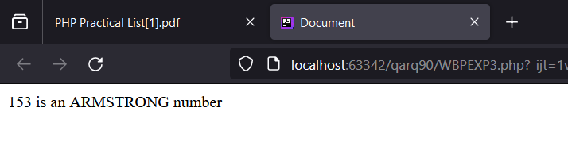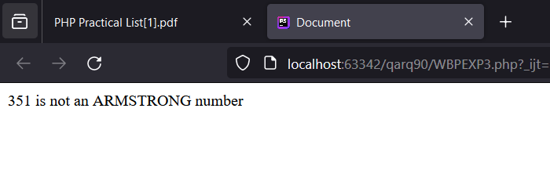

**2) Write a Program to print whether the number is a palindrome or not**

**CODE:**

<!DOCTYPE html>  
<html lang="en">  
<head>  
 <meta charset="UTF-8">  
 <meta name="viewport" content="width=device-width, user-scalable=no, initial-scale=1.0, maximum-scale=1.0, minimum-scale=1.0">  
 <meta http-equiv="X-UA-Compatible" content="ie=edge">  
 <title>Document</title>  
 <?php  
 $num = 212;  
 function WBPEXP2($num): void{  
 $rev = 0;  
 $temp = $num;  
 while ($temp > 0){  
 $n = $temp % 10;  
 $rev = $rev * 10 + $n;  
 $temp = (int) ($temp / 10);  
 }  
 if ($rev == $num) {  
 echo $num . " is a PALINDROME number";  
 } else {  
 echo $num . " is not a PALINDROME number";  
 }  
 }  
 WBPEXP2($num);  
 ?>  
</head>  
<body>  
  
</body>  
</html>

**OUTPUT:**

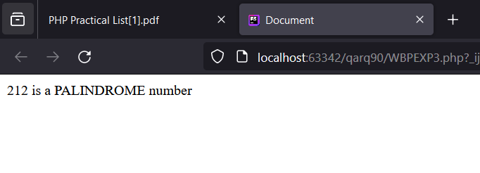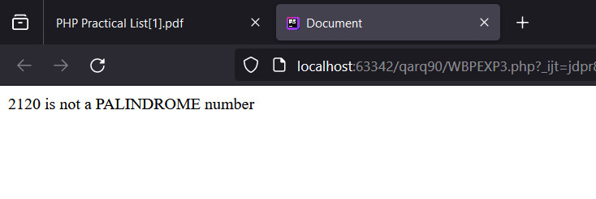

**3) Write a Program to check if number is prime or not via for loop**

**CODE:**

<!DOCTYPE html>  
<html lang="en">  
<head>  
 <meta charset="UTF-8">  
 <meta name="viewport" content="width=device-width, user-scalable=no, initial-scale=1.0, maximum-scale=1.0, minimum-scale=1.0">  
 <meta http-equiv="X-UA-Compatible" content="ie=edge">  
 <title>Document</title>  
 <?php  
 $num = 7;  
 function WBPEXP2($num): void{  
 $check = true;  
 for ($i = 2 ; $i <= $num / 2 ; $i++){  
 if ($num % $i == 0){  
 $check = false;  
 break;  
 }  
 }  
 if ($num > 1 && $check) {  
 echo $num . " is a prime number";  
 } else {  
 echo $num . " is not a prime number";  
 }  
 }  
 WBPEXP2($num);  
 ?>  
</head>  
<body>  
  
</body>  
</html>

**OUTPUT:**

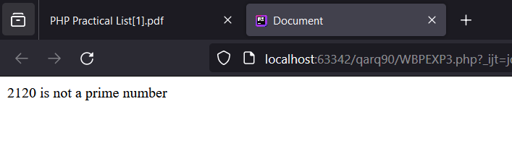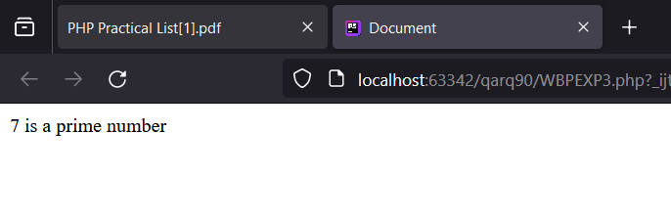

**4) Write a Program to print right angled triangle**

**CODE:**

<!DOCTYPE html>  
<html lang="en">  
<head>  
 <meta charset="UTF-8">  
 <meta name="viewport" content="width=device-width, user-scalable=no, initial-scale=1.0, maximum-scale=1.0, minimum-scale=1.0">  
 <meta http-equiv="X-UA-Compatible" content="ie=edge">  
 <title>Document</title>  
 <?php  
 $num = 7;  
 function WBPEXP2($num): void{  
 $i = "* ";  
 $k = 1;  
 while ($k <= $num){  
 echo $i . "<br>";  
 $i .= "* ";  
 $k++;  
 }  
 }  
 WBPEXP2($num);  
 ?>  
</head>  
<body>  
  
</body>  
</html>

**OUTPUT:**

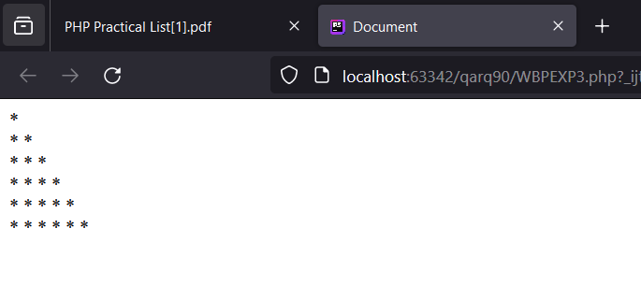

**5) Write a Program to print equilateral triangle.**

**CODE:**

<!DOCTYPE html>  
<html lang="en">  
<head>  
 <meta charset="UTF-8">  
 <meta name="viewport" content="width=device-width, user-scalable=no, initial-scale=1.0, maximum-scale=1.0, minimum-scale=1.0">  
 <meta http-equiv="X-UA-Compatible" content="ie=edge">  
 <title>Document</title>  
 <?php  
 $num = 7;  
 function WBPEXP2($num): void{  
 for ($i = 1; $i <= $num; $i++) {  
 echo str_repeat('&nbsp;&nbsp;&nbsp;', $num - $i);  
 echo str_repeat('* ', 2 * $i - 1);  
 echo "<br>";  
 }  
 }  
 WBPEXP2($num);  
 ?>  
</head>  
<body>  
  
</body>  
</html>

**OUTPUT:**

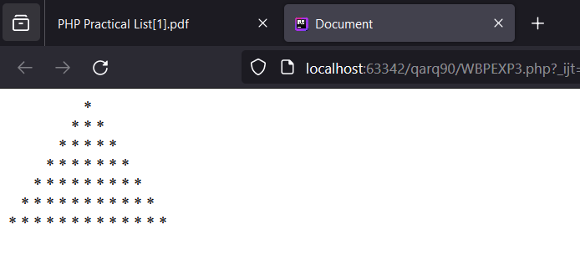

**6) Write a Program to print a Fibonacci series**

**CODE:**

<!DOCTYPE html>  
<html lang="en">  
<head>  
 <meta charset="UTF-8">  
 <meta name="viewport" content="width=device-width, user-scalable=no, initial-scale=1.0, maximum-scale=1.0, minimum-scale=1.0">  
 <meta http-equiv="X-UA-Compatible" content="ie=edge">  
 <title>Document</title>  
 <?php  
 $num = 7;  
 function WBPEXP2($num): void{  
 $t1 = 0;  
 $t2 = 1;  
 echo $t1 . "<br>" . $t2 . "<br>";  
 for ($i = 1; $i <= $num; $i++) {  
 $t3 = $t1 + $t2;  
 echo $t3 . "<br>";  
 $t1 = $t2;  
 $t2 = $t3;  
 }  
 }  
 WBPEXP2($num);  
 ?>  
</head>  
<body>  
  
</body>  
</html>

**OUTPUT:**

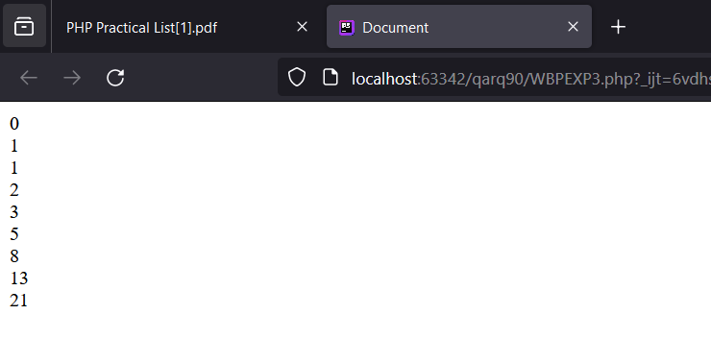

**7) Write a Program to create a Menu Driven Program using do while loop.**

**CODE:**

<!DOCTYPE html>  
<html lang="en">  
<head>  
 <meta charset="UTF-8">  
 <meta name="viewport" content="width=device-width, user-scalable=no, initial-scale=1.0, maximum-scale=1.0, minimum-scale=1.0">  
 <meta http-equiv="X-UA-Compatible" content="ie=edge">  
 <title>Document</title>  
 <?php  
 $numA = 10;  
 $numB = 20;  
 $num = 1;  
 do {  
 echo "1. Sum<br>";  
 echo "2. Minus<br>";  
 echo "3. Product<br>";  
 echo "4. Division<br>";  
 echo "5. Exit<br>";  
 $choice = $num;  
 echo "Enter your choice: ".$choice."<br>";  
 $num++;  
 switch ($choice) {  
 case 1:  
 $res = $numA + $numB;  
 echo "Sum: . $numA . and . $numB . is $res<br>";  
 break;  
 case 2:  
 $res = $numA - $numB;  
 echo "Minus: . $numA . and . $numB . is $res<br>";  
 break;  
 case 3:  
 $res = $numA * $numB;  
 echo "Product: . $numA . and . $numB . is $res<br>";  
 break;  
 case 4:  
 $res = $numA / $numB;  
 echo "Division: . $numA . and . $numB . is $res<br>";  
 break;  
 case 5:  
 exit;  
 default:  
 echo "Invalid choice<br>";  
 }  
 } while ($choice != 5);  
  
 ?>  
</head>  
<body>  
  
</body>  
</html>

**OUTPUT:**

